LEAD SOURCES
Dealer may setup an unlimited number of sources through administration portal at no additional charge.
Dealer login will be provided upon setup. Fast Ring will setup the dealer’s first 5 sources listed below.
1 | Source Information |  | Routing Method | Call Recording* | Notes/Additional Information
 | Name: |  | Simultaneous  Sequential  Round Robin | Enable*
 | Website: www. _______________________
 | Contact Name: |  | Contact Phone #:
 | Contact Email:
2 | Source Information |  | Routing Method | Call Recording* | Notes/Additional Information
 | Name: |  | Simultaneous  Sequential  Round Robin | Enable*
 | Website: www. _______________________
 | Contact Name: |  | Contact Phone #:
 | Contact Email:
3 | Source Information |  | Routing Method | Call Recording* | Notes/Additional Information
 | Name: |  | Simultaneous  Sequential  Round Robin | Enable*
 | Website: www. _______________________
 | Contact Name: |  | Contact Phone #:
 | Contact Email:
4 | Source Information |  | Routing Method | Call Recording* | Notes/Additional Information
 | Name: |  | Simultaneous  Sequential  Round Robin | Enable*
 | Website: www. _______________________
 | Contact Name: |  | Contact Phone #:
 | Contact Email:
5 | Source Information |  | Routing Method | Call Recording* | Notes/Additional Information
 | Name: |  | Simultaneous  Sequential  Round Robin | Enable*
 | Website: www. _______________________
 | Contact Name: |  | Contact Phone #:
 | Contact Email:
*NOTES: (1) “DISPLAYED CALLER ID” is the phone number the customer will see when their phone rings. This will be the default caller id unless specified. (2) “Call Recording” – The following states are not eligible for call recording due to privacy laws: California, Connecticut, Delaware, Florida, Massachusetts, Maryland, Michigan, Montana, New Hampshire, Pennsylvania, & Washington.

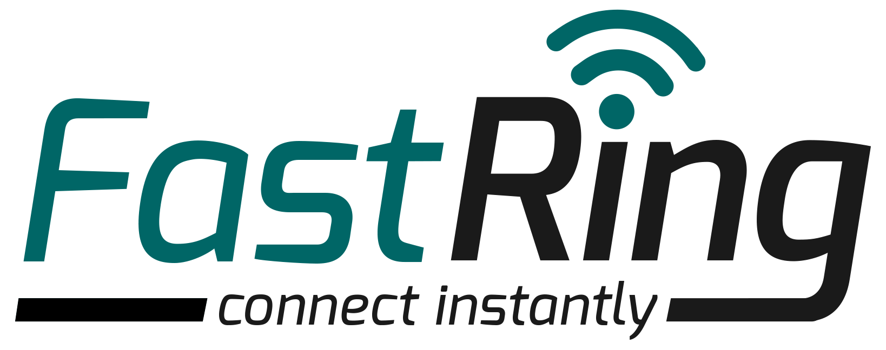
PLEASE FAX COMPLETED SETUP FORM TO (310) 919-3765
http://www.fastring.com - support@fastring.com

